CHAPTER 2-1

finite state machines

- The simplest and most efficient computational device is FSM, also called finite state automaton (FSA)
- The input to a FSM is a string, and the output is 1 of 2 values: accept and reject.
- A FSM is like a TM, except it is simpler. In particular, a FSM has no memory (no tape, no rw head). It can only change state based on the current input symbol and the current state of the FSM.

Deterministic FSM (DFSM)

- The class of FSMs whose behavior is deterministic is called DFSM.
- In a DFSM, there is always exactly __________ legal move that can be made at each step.
- A DFSM is defined by the quintuple M=(K, Σ, δ, s, A) where
- K is a finite set of states
- Σ is a finite set of symbols called the input alphabet
- δ:KXΣ→K is the transition function
- s∈K is the start state
- A⊆K is the set of final states (or accepting states)
- A DFSM works as follows:
- It starts at s, with its input mechanism on the leftmost symbol of the input string.
- During each move of the automaton, the input mechanism reads exactly 1 symbol.
- Each input letter puts the DFSM in another state, according to δ.
- The DFSM stops when the last input letter has been read. The string is accepted if the DFSM is in 1 of its final states. Otherwise, the string is rejected.
- A configuration of M is denoted by (currentState, inputStringLeft).
- The initial configuration of M, on input w is (s, w).
- M halts immediately after reading the last character of its input.
  - Every DFSM, on input w, halts after |w| steps.
- The language accepted by M, L(M), is the set of all strings accepted by M.

Ex2-1-1 Let L={w∈{a,b}*:every a is immediately followed by a b}. L can be accepted by the DFSM M=({q₀, q₁, q₂}, {a,b}, δ, q₀, {q₀}) where δ is given by
δ(q₀, a)= q₁, δ(q₀, b)= q₀
δ(q₁, a)= q₂, δ(q₁, b)= q₀
δ(q₂, a)= q₂, δ(q₂, b)= q₂
This formal notation is hard to read. Thus, to represent a DFSM, we typically use a graph.
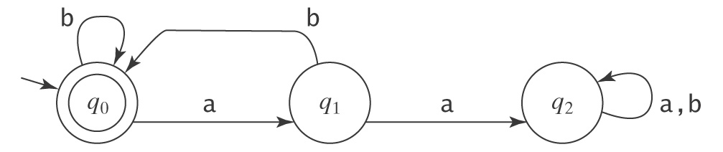
As an example of M's operation, consider the input string abbabab. M's computation is a sequence of configurations: (q₀, abbabab), ___________________________________________________

Ex2-1-2 What language does this DFSM accept?
b a,b
-

a a, b
+

The same language can be accepted by the following DFSM:
b a,b
-

a a, b a, b
+
+

Ex2-1-3 What language does this DFSM accept?
a,b
±

Ex2-1-4 What language does this DFSM accept?
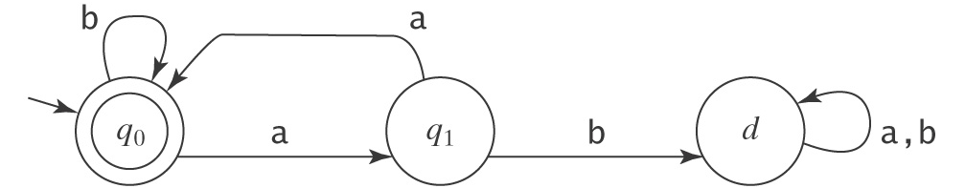

Ex2-1-5 What language does this DFSM accept?
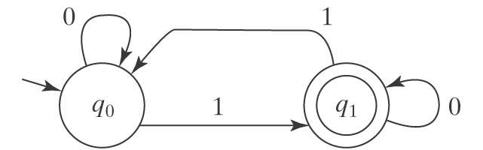

Ex2-1-6 What language does this DFSM accept?
a, b a,b
-

Ex2-1-7 What language does this DFSM accept?
b a
a a
-q₀
q₂
+q₃

b
b
q₁
a,b

Ex2-1-8 What language does this DFSM accept?
a
-

b
b a
+
b a

Ex2-1-9 What language does this DFSM accept?
a,b
a a
-q₀
q₁
q2

b b a
+q3
b

Regular languages

- Every DFSM accepts some language. If we consider all possible DFSMs, we get a set of languages associated with them. This set of languages is called regular languages.
- A language L is regular iff there exits some DFSM M such that L=L(M).

Ex2-1-10 Is L={w∈{a, b}*:w contains no more than 1 b} regular?

Ex2-1-11 Prove L={w∈{a, b}*:no 2 consecutive characters are the same} is regular.

Omitting dead states

- Each state in a DFSM has |Σ| outgoing edges. If |Σ| is large, a DSFM would become too unwieldy to be useful.
- To simplify the drawings of DFSMs, we will not include dead states. Our convention is that if there is no transition specified for some (state, input) pair, then that pair drives the machine to a dead state.

Ex2-1-12 Let FLOAT={w:w is the string representation of a floating point number}
A floating point number is an optional sign, followed by a decimal number, followed by an optional exponent. A decimal number may be of the form x or x.y, where x and y are nonempty strings of decimal digits. An exponent begins with E and is followed by an optional sign and then an integer. An integer is a nonempty string of decimal digits. E.g. +3.0, 3.0, 0.3E1, 0.3E+1, -0.3E+1, -3E8. Note that Σ={+, -, ., E, 0, 1, 2, 3, 4, 5, 6, 7, 8, 9}. Is FLOAT regular?
Yes, because it can be accepted by
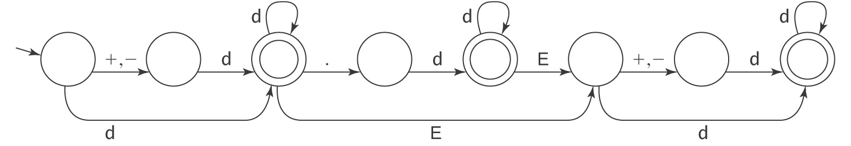

Memory in DFSMs

- A DFSM has no memory storage. A finite amount of information can be retained in the control unit by placing the DFSM into a specific state. But since the number of such states is finite, a DFSM can only deal with situations in which the information to be "remembered" at any time is strictly bounded.

Ex2-1-13 Design a DFSM that accepts all strings on Σ={0,1} except those containing the substring 001.

Ex2-1-15 Design a DFSM that accepts L={w∈{a, b}*:w contains an even number of a’s and an odd number of b’s}.

Ex2-1-16 Design a DFSM that accepts all strings on Σ={0,1} that contain the substring 001.

The practicality of DFSMs

Ex2-1-17 Let LMissing ={w: w does not contain all letters in the alphabet Σ, where Σ={a,b,c,d}}. Design a DFSM M to accept it.

Homework problems

- Build a DFSM for each of the following languages:
  - {w ∈ {a, b}* : every a in w is immediately preceded and followed by b}.
  - {w ∈ {a, b}* : w does not end in ba}.
  - {w∈{0-9}*:w corresponds to the decimal encoding without leading 0s, of an odd natural number}.
  - {w ∈ {a, b}* : w has bbab as a substring}.
  - {w ∈ {0, 1}* : none of the prefixes of w ends in 0}.

- Give 2 strings this DFSM accepts. Give 2 strings this DFSM does not accept. What language
does this DFSM accept?
-

+
a a a a,b
b
b b a b
a

b

- If M is a DFSM and ε ∈ L(M), what simple property must be true of M?

